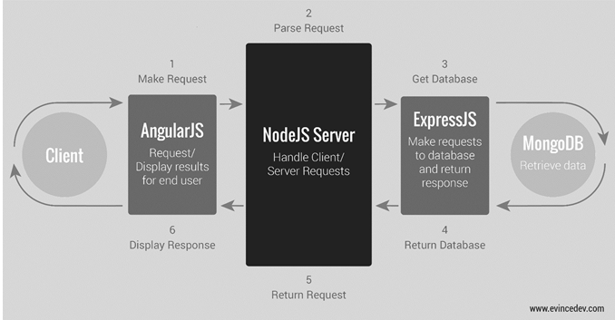

1. Install MongoDB from <https://www.mongodb.com/download-center/community> in MSI format file.
2. Go to C:\Program Files\MongoDB\Server\4.0\data and create a folder named ‘db’.
3. Then go to C:\Program Files\MongoDB\Server\4.0\bin and open the cmd mode in git bash.
4. Type ‘mongod’ and it will show a long list of things.
5. Same again, go to the C:\Program Files\MongoDB\Server\4.0\bin and open the cmd in git bash.
6. Type ‘mongo’ and then something will show up.
7. Now in the same node type ‘cls’ and type ‘show dbs’, which will show list of databases.
8. In order to create database, inside the same node terminal, type ‘use DATABASE_NAME’ which will automatically create and and take you to the database.